I finished all the tasks. Firstly, I implement light calibration. Secondly, I implement NormalMap. Then I used NormalMap to get albedo. Finally, I used the NormalMap to fill the sparsedMetrc and get depthX, depthY and depth. Here are the pictures come out below:

light calibration:

[0.50350821, 0.47203898, 0.72364259;

0.25142819, 0.1508569, 0.9560473;

-0.033745803, 0.18560192, 0.98204541;

-0.098861836, 0.44487825, 0.89011776;

-0.32118183, 0.51389092, 0.79546094;

-0.11276831, 0.57995135, 0.80680859;

0.27740273, 0.44058082, 0.85377777;

0.098861836, 0.44487825, 0.89011776;

0.2154585, 0.34804833, 0.91238153;

0.083315589, 0.34992546, 0.93306518;

0.13523732, 0.05071399, 0.98951459;

-0.14916356, 0.38119578, 0.91238153]

Normal:

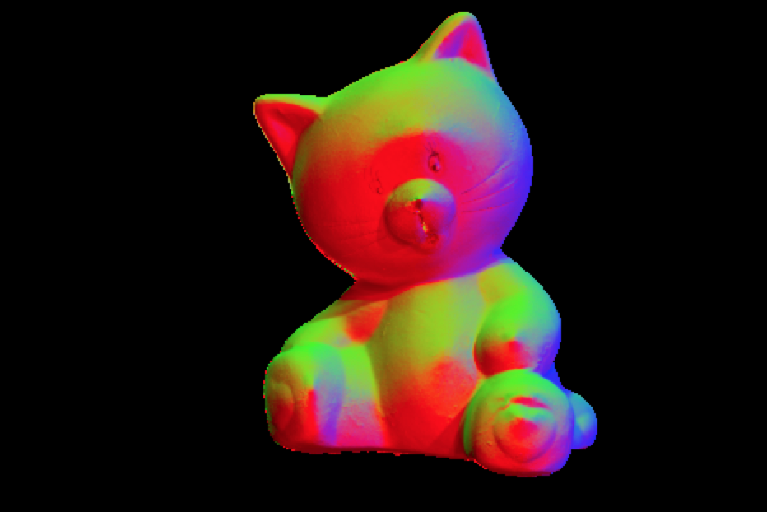

albedo:



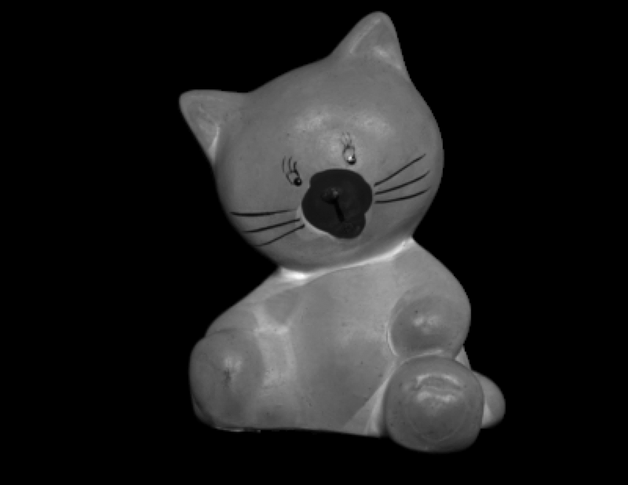





depthX:

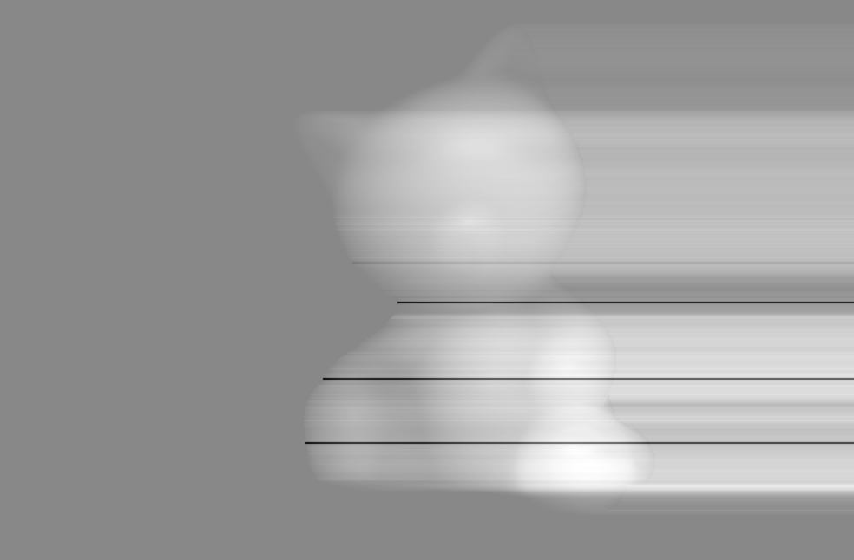

depthY:

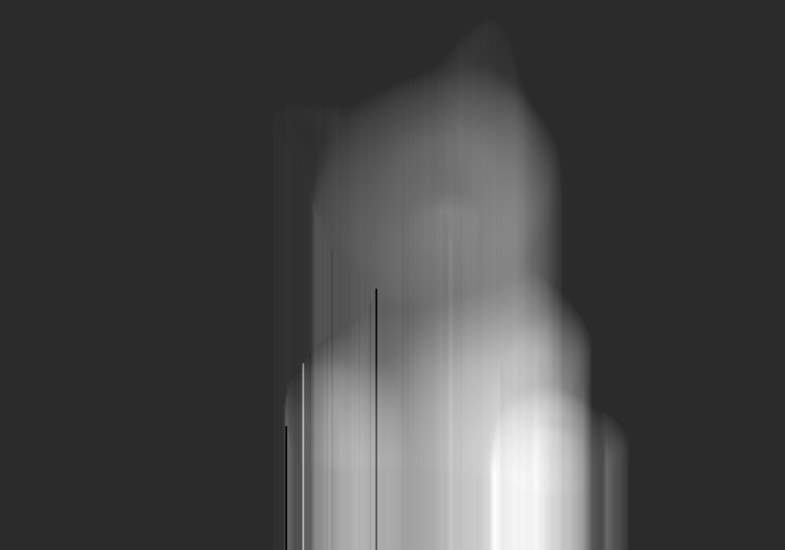

depth:

